ĐỀ THI TIẾNG ANH Mã đề: 11
Trình độ A2
Họ và tên thí sinh: ……………..……………………………………………………….……………………………………………………………….
Số báo danh: ……………..…………………………………………...……. Phòng thi số: …………………………….…………………

PAPER TWO LISTENING (Approximately 15 minutes)
PART 1: Questions 1 – 5
There are five questions in this part. For each question there are three answer choices and a short recording. Tick (√) the correct answer. You will hear the piece twice.
Example: How many new T-shirts did Ellen get?
A. 2 B. 5 √ C. 7

1. Where is Justin’s sister now?
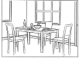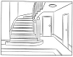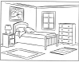
A □ B □ C □
2. How much money is in Eva’s purse?

A □ B □ C □
3. Where is Paul’s textbook?
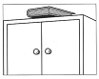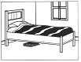
A □ B □ C □
4. What’s Jenna doing now?
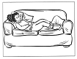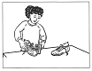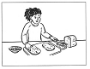
A □ B □ C □
5. What must Andy put in his school bag next?
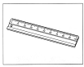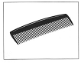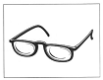
A □ B □ C □

PART 2: Questions 6-10
Listen to Joel telling his older sister about his friends. Where would they like to work one day?
For questions 6-10, write a letter A-H next to the person. You will hear the conversation twice.
EXAMPLE | ANSWER
0 Alice | G
Friends |  | Work place
6 Milton  7 Saskia  8 Elise  9 Lydia  10 Ali |  | A hotel  B park  C police station  D restaurant  E school  F sports stadium  G television centre  H zoo

PART 3: Questions 11-15
Listen to Bruno asking about a museum that is in the countryside.
For each question, choose the right answer A, B, or C. You will hear the conversation twice.
Example: 0. How long has the museum been open?
A. a week
√ B. two months
C. three years

11. The museum has a lot of information about?
A. forest workers
B. wild birds
C. different trees
12. When is the museum closed?
A. at home
B. in an Italian restaurant
C. in a Chinese restaurant
13. How far away is the museum?
A. 15 miles
B. 20 miles
C. 30 miles
14. On the study day, teenagers can learn about
A. plants
B. the sea
C. clouds
15. The study day is free for children under
A. 14
B. 16
C. 18

